

**[[1]](#footnote-1)**

L.M. Geoinformatics Engineering

AA 2021/21

HYPERMEDIA APPLICATIONS

Design Document

**Date**:

# **Authors**: Matteo Bresciani – mtr. …….. – matteo.bresciani@mail.polimi.it

Gabriele D’Ascoli – mtr. 944275 - gabrieleangelo.dascoli@mail.polimi.it

**Link: https://toptech-polimi.herokuapp.com/**

**Contents**

[**1.** **Abstract**…………………………………………………………………………………………………………………………………………………………..3](file:///C:\Users\ThinkPad\Desktop\Hypermedia\documentazione\DESIGNDOC_.docx#_Toc74144743)

[**2.** **Graphical Representation**…………………………………………………………………………………………………………………………..4](file:///C:\Users\ThinkPad\Desktop\Hypermedia\documentazione\DESIGNDOC_.docx#_Toc74144744)

[2.1 C-IDM Diagram 4](file:///C:\Users\ThinkPad\Desktop\Hypermedia\documentazione\DESIGNDOC_.docx#_Toc74144745)

[2.2**.** P-IDM Diagram 4](file:///C:\Users\ThinkPad\Desktop\Hypermedia\documentazione\DESIGNDOC_.docx#_Toc74144746)

[**3.** **Content Tables** 7](file:///C:\Users\ThinkPad\Desktop\Hypermedia\documentazione\DESIGNDOC_.docx#_Toc74144747)

[**4.** **Mapping Content Tables into Pages** 8](file:///C:\Users\ThinkPad\Desktop\Hypermedia\documentazione\DESIGNDOC_.docx#_Toc74144748)

[**5.** **Visual Design (Wireframe and screenshots)** 9](file:///C:\Users\ThinkPad\Desktop\Hypermedia\documentazione\DESIGNDOC_.docx#_Toc74144749)

[5.1 Commented low fidelity wireframes 9](file:///C:\Users\ThinkPad\Desktop\Hypermedia\documentazione\DESIGNDOC_.docx#_Toc74144750)

[5.2 Commented high fidelity wireframes 9](file:///C:\Users\ThinkPad\Desktop\Hypermedia\documentazione\DESIGNDOC_.docx#_Toc74144751)

[**6.** **Scenarios** 10](file:///C:\Users\ThinkPad\Desktop\Hypermedia\documentazione\DESIGNDOC_.docx#_Toc74144752)

[6.1 Case 1 10](file:///C:\Users\ThinkPad\Desktop\Hypermedia\documentazione\DESIGNDOC_.docx#_Toc74144753)

[6.1.1 Textual narrative 10](file:///C:\Users\ThinkPad\Desktop\Hypermedia\documentazione\DESIGNDOC_.docx#_Toc74144754)

[6.1.2 Sequence 10](file:///C:\Users\ThinkPad\Desktop\Hypermedia\documentazione\DESIGNDOC_.docx#_Toc74144755)

[6.2 Case 2 12](file:///C:\Users\ThinkPad\Desktop\Hypermedia\documentazione\DESIGNDOC_.docx#_Toc74144756)

[6.2.1 Textual narrative 13](file:///C:\Users\ThinkPad\Desktop\Hypermedia\documentazione\DESIGNDOC_.docx#_Toc74144757)

[6.2.2 Sequence 13](file:///C:\Users\ThinkPad\Desktop\Hypermedia\documentazione\DESIGNDOC_.docx#_Toc74144758)

[6.3 Case 3 14](file:///C:\Users\ThinkPad\Desktop\Hypermedia\documentazione\DESIGNDOC_.docx#_Toc74144759)

[6.3.1 Textual Narrative 15](file:///C:\Users\ThinkPad\Desktop\Hypermedia\documentazione\DESIGNDOC_.docx#_Toc74144760)

[6.3.2 Sequence 15](file:///C:\\Users\\ThinkPad\\Desktop\\Hypermedia\\documentazione\\DESIGNDOC_.docx" \l "_Toc74144760)

**[7.](file:///C:\\Users\\ThinkPad\\Desktop\\Hypermedia\\documentazione\\DESIGNDOC_.docx" \l "_Toc74144761)****[DB Design \_\_\_\_\_\_\_\_\_\_\_\_\_\_\_\_\_\_\_\_\_](file:///C:\\Users\\ThinkPad\\Desktop\\Hypermedia\\documentazione\\DESIGNDOC_.docx" \l "_Toc74144761)** [\_\_\_\_\_\_ 18](file:///C:\\Users\\ThinkPad\\Desktop\\Hypermedia\\documentazione\\DESIGNDOC_.docx" \l "_Toc74144761)

[7.1 Relational Tables 15](file:///C:\Users\ThinkPad\Desktop\Hypermedia\documentazione\DESIGNDOC_.docx#_Toc74144760)

[7.2 ER 15](file:///C:\Users\ThinkPad\Desktop\Hypermedia\documentazione\DESIGNDOC_.docx#_Toc74144760)

1. **Abstract**

This document contains the decisions made regarding the design specification of the project of the Hypermedia Application (Web and Multimedia) course for the academic year 2020/2021.

The project consists in designing and implementing a website for an ICT company.

The document is composed by the IDM models (interactive dialogue model) that define which are the main concept of the website (C-IDM) also providing a logical description of the pages structure (P-IDM), the scenarios to better understand the main idea behind the navigation and the contents provided by the website the content tables with their mapping with the pages, then the low and high fidelity wireframes of our website and how it will look like after the development and at the end the Entity Relationship diagram that describe the structure of the database.

**Every decision has been made in order to optimize the content of the website, making it simple and attractive.**

**Diagrams and Wireframes are created using *draw.io and Figma***

1. **Graphical Representation**

2.1 C-IDM

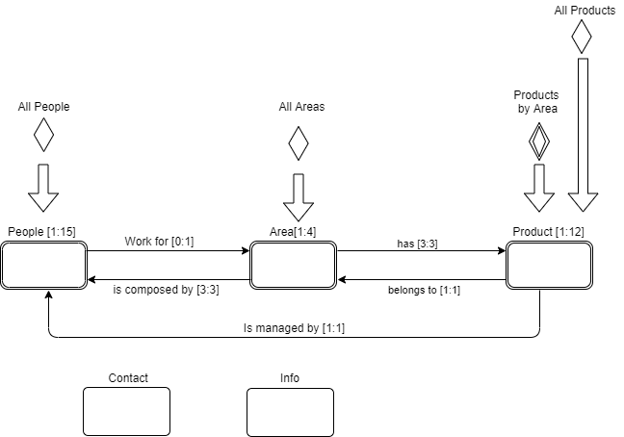

Figura 1 C-IDM describes the content of the web site in the large

2.2 P-IDM

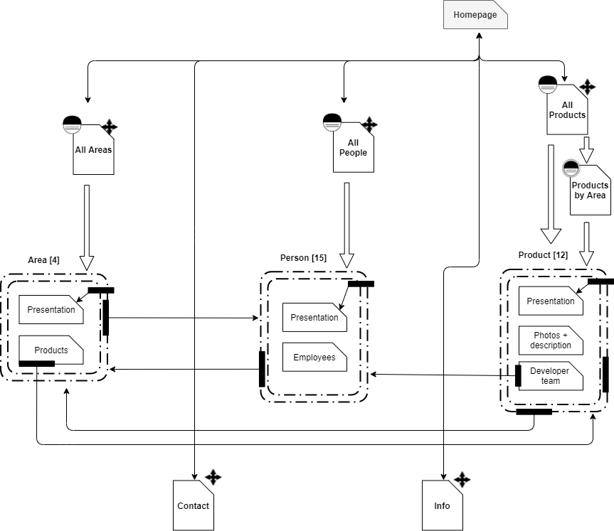

*Figure 2: Page Interactive Dialogue Model*

1. Content tables

Content tables describe the content of our website in the small.

Each component of the C-IDM Diagram corresponds to a table.

|  |
| --- |
| **GROUP OF TOPICS: All areas** |
| ***Page description*:** Text (max 100 words) |
| ***Items Preview*:**LIST OF [Area image; Area name; Area description] |

|  |
| --- |
| **GROUP OF TOPICS: All people** |
| ***Group Title*:** “People” |
| ***Page presentation*:** <Image, Caption:text (max 100 words)> |
| ***Items Preview*:**LIST OF [Area name, LIST OF (Person image; Person name; Person role)] |

|  |
| --- |
| **GROUP OF TOPICS: All products** |
| ***Title*:** “Products” |
| ***Items Preview*:**LIST OF [Product image; Product name; Brief Description] |
| ***Development strategies:*** [<Image1, Caption:text>, <Image2, Caption:text>, <Image3, Caption:text>] |

|  |
| --- |
| **KIND OF TOPIC: Areas** |
| ***Area Name****:*Text (max 30 char) |
| ***Area brief description:*** [<Image1, Caption:text>, <Image2, Caption:text>, <Image3, Caption:text>] |
| ***Area long description*:**[Image1, Text1 ( max 300 words), Image2, Text2 ( max 300 words), Image3, Text3 ( max 300 words)] |
| ***Bestselling:*** “Bestselling” |
| ***Bestselling product:*** [Image, Name, Text (max 50 char)] |
| ***Supervisor:*** “Supervisor” |
| ***Area manager:***[Person image; Person name, Person role] |

|  |
| --- |
| **KIND OF TOPIC: Products** |
| ***Product Name****:*Text (max 30 char) |
| ***Product image:*** Image |
| **Product long description:**Text (max 300 words) |
| ***Functionalities section*:** “Functionalities” |
| ***Product functionalities***: [Text1 ( max 50 words), Text2 ( max 50 words), Text3 ( max 50 words)] |
| ***Collaborations section:*** “Collaborations” |
| ***Related Team:***[Area image; Text (max 100 char)] |
| ***Related Area manager:***[Person image; Person name, Person role] |

|  |
| --- |
| **KIND OF TOPIC: People** |
| ***Anagrafic title:*** “Anagrafic” |
| ***Person anagrafic/image/citation/contribution:*** [Text1 (max 50 char), image, Text2 (max 50 words), Text3 (max 50 words)] |
| ***Contributions title:*** “Contributions” |
| ***Managed Products:*** LIST OF[Product image; Product name; Text (max 50 char)] |

|  |
| --- |
| **TOPIC: Contact** |
| ***Title*:** ”Get in touch with us!” |
| ***Practical info/addresses/contacts:*** [Text1 (max 50 words), Text2 (max 50 words), Text3 (max 50 words), Text4 (max 50 words)] |
| ***Form title:*** “Contact us!” |
| ***Contact us /form:*** multipart/ form-data |

|  |
| --- |
| **TOPIC: About Us** |
| ***Title*: “**About Us” |
| ***Overview*:** [4 images, Text1 (max 300 words), Text2 (max 300 words), Text3 (max 300 words), Text4 (max 300 words)] |
| ***Leadership team title:* “**Leadership team” |
| ***Leadership team overview***: [ 3 images, Name1 ( max 50 words), Name2 ( max 50 words), Name3 ( max 50 words)] |

1. Mapping Content Tables into Pages

The mapping of the content tables is useful if the content of one or more tables is divided over several pages.

In our case, each table corresponds to a single page of the website.

This chapter would be a repetition of the previous one.

*See chapter 3. Content tables*

1. Visual Design (Wireframes and Screenshots)
   1. Commented low fidelity wireframes
   2. Commented high fidelity wireframes
2. Scenarios

The following chapter will focus on the presentation of general scenarios, which are “a narrative description of what people do and experience as they try to make use of computer systems and applications” (M. Carrol, “Scenario-based Design”, Wiley, 1995). Each scenario describes a possible usage of the web site by the users in real life and presented in order of complexity.

6.1 Case 1

6.1.1 Textual narrative

**User profile**: a graduating computer engineer is looking for a company that will give him the opportunity to do an internship in the software development sector after graduation

**Goals**: the user wants to contact the company to get information on vacant positions and to give his availability

**Context**: the user visits the TopTech company website during a study break, looking for a way to submit his application

**Tasks**: the user navigates through the sections of the website, accesses the Contacts section and fills out the appropriate form to communicate with the company by entering his data

6.1.2 Sequence

6.2 Case 2

6.2.1 Textual narrative

**User profile**: a scientific informant in the IT sector is carrying out an IT company monitoring campaign on behalf of a company that deals with market analysis

**Goals**: the user acquires information from the company's website about the best-selling product in the IoT sector among those proposed by the TopTech company

**Context**: the expert within the monitoring campaign for which he is collaborating visits the TopTech website in search of the data he needs for his market analysis

**Tasks**: the user visits the website of the TopTech company, navigates between the various sections and accesses the one relating to the treated areas; once you have chosen the IoT area you are interested in, you can view the bestselling product in that area and the page relating to it with all its technical specifications and funcionalities

6.2.2 Sequence

6.3 Case 3

6.3.1 Textual narrative

**User profile**: the data processing manager of a bank branch is testing a new TopTech Security IT sector product and is unable to fully utilize a particular feature

**Goals**: the customer wants to contact the TopTech project manager responsible for product development to ask him for clarification on the use of the purchased product

**Context**: the data processing manager, approaching the use of the new product at his workplace with data relating to the bank's customers, visits the TopTech website in search of information regarding the development team of the purchased product and a way to contact the project manager directly

**Tasks**: the customer visits the website of the TopTech company, navigates between the sections of the site and accesses the Products section; at this point he searches for the purchased product among those offered by the company, accesses its relative page within which he will find the person at the head of the research team. At this point, the customer accesses the project manager's card and, by entering their data, uses the appropriate contact form to interact directly with the manager and expose the matter to him

6.3.2 Sequence

1. DB Design
   1. Relational tables
   2. ER

1. [↑](#footnote-ref-1)